**NEW ERRORS FOUND:**

—------------------

When selecting “Insert a new row before/after” and inputting a value, the value ends up getting added to the bottom of the column instead of the selected row.

For example, if you entered a value in the highlighted cell then hit Enter, it will incorrectly be added to the bottom of the dataset.

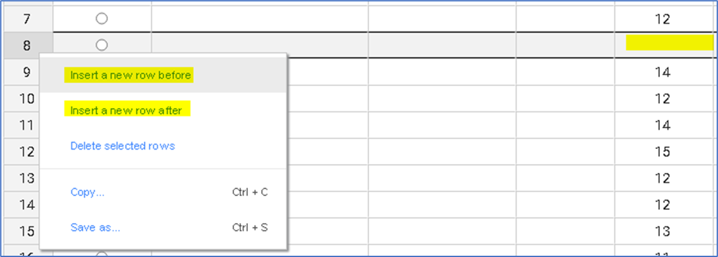

—----------------------------

Not able to enter anything beyond 3 digits.

For example, if I enter a value of 4,000 then hit enter, the code is automatically changing it to a “4”.

If there needs to be a digit limit, maybe we can change to 5 instead of 3 (???)

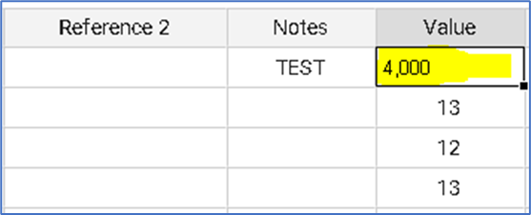

—---------------------------------------------

Can you make sure that Center Lines are in the background when they’re the same value as the Average or Range?  
The process output lines should always appear in the front when overlapped, and all Control Limits and Center Lines should be in the background.

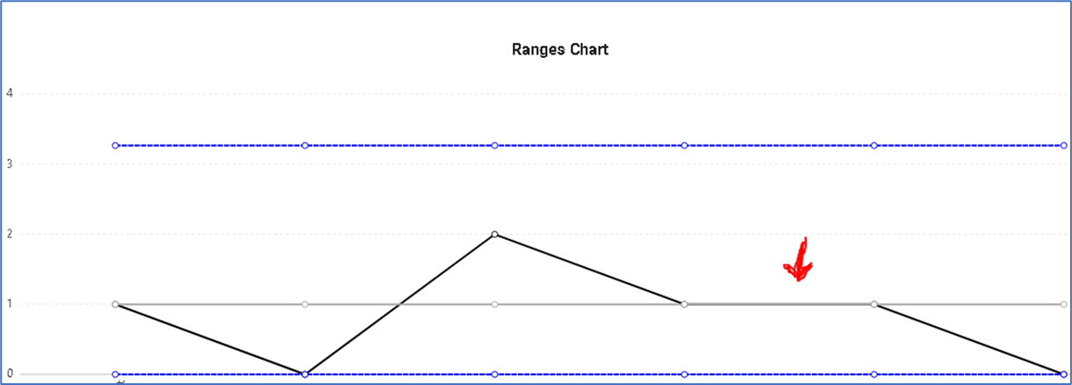

—-------------------------------------

When pasting in data, the chosen Lock Limits location isn’t being reflected on the charts right away:

For example, create a subgroup 1 chart and paste in about 30 values. Without doing any other edits, you’ll see that the Control Limits displayed on the charts are incorrectly based on the overall dataset (the bottom cumulative values).

The page is requiring you to make a manual change to the data for the correct Control Limits to be displayed (such as adding a new value or moving the Lock Limits position).

Can you make sure that it immediately displays the correct Control Limits?

—--------------------------------------------

**FUNCTIONALITY IMPROVEMENTS:**

Can a “Refresh & Save Changes” button be added?

Here’s an example of how I picture the Refresh & Save Changed button working:

Let’s say that you had 9 values in your chart, then highlighted 7 of them and hit “delete” on keyboard. So then it looks like this:  
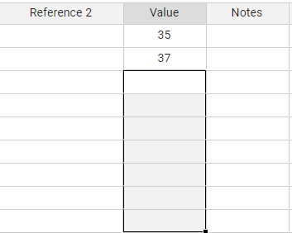

As it stands right now, those changes don’t get reflected without double-clicking inside of a cell and hitting Enter. If all you did was hit “refresh” in the browser, you’d end up having all 9 values re-appear. I could picture a user being under the impression that the changes were already saved, when they were in fact not.

Instead, maybe a “Refresh & Save Changes” button could be in the left margin that can be pressed, which does the same thing as a double-click and [Enter] would have.

—------------------------------------------------------------

If the user deletes cells in the beginning/middle/end of dataset and hits “enter”, can we just make those blank rows disappear?-

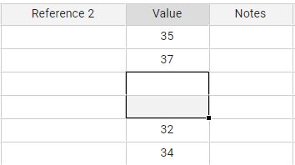

After hitting enter (or the “Refresh & Save Changes” button described above), it should automatically become:   
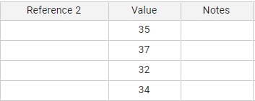

—------------------------------------------------------------------------

Ideally, would like ability to “rapid enter” values down a column, versus having to move the mouse over to the next cell after each value entry. For a simulation; Open an Excel sheet and start adding values down a single column with just your keyboard arrows.

Also you’ll notice that in Excel, if you hit Enter, the next cell is hovered versus making you place your mouse back onto the next cell.

—------------------------------------------

Need to discuss the “undo” button feature, and how it might be accomplished. (In the least,ability to undo the 1 previous change?)

—---------------------------------------------

Does every page load have to automatically re-position?

For example, after entering a new value and hitting Enter, the page is automatically shifting back to the top-left:  
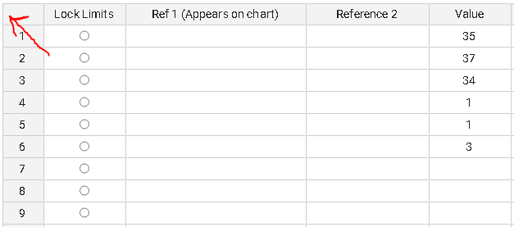

—----------------------------------------------

We should probably change “Edit Columns” to “Column Titles”:  


—-------------------------------------------

Can you “hide” these highlighted rows for now?:

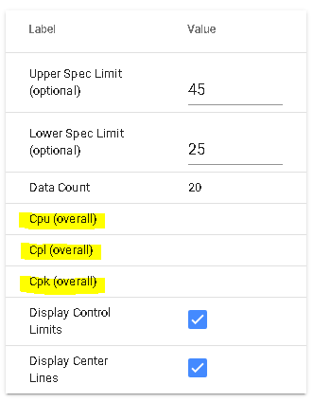

—--------------------------------------------

Depending on time required, would like 2 more checkboxes:

* Display Cpk
* Display Ppk

—----------------------------------------------

Change to “Process Capability & Performance Ratios (Cumulative)

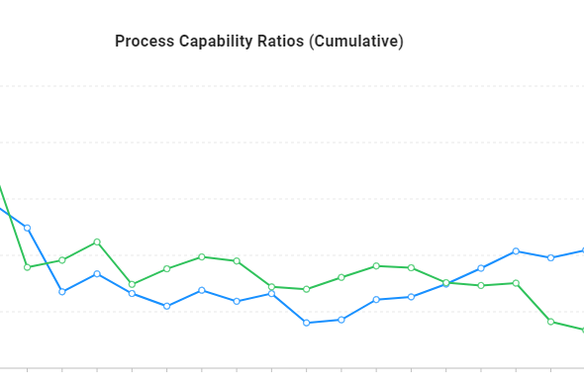

—--------------------------------------------

**TASKS BEFORE PUBLIC LAUNCH:**

- Email verification link at signup and message that account was registered.

- Hide the cumulative values columns from the chart space (after we confirm all calculations are correct).

- Integrate in menu with logo, and homepage

- Deploy to spccharts domain